|  |
| --- |
| Email: |
| Address: |
| Telephone: |
| Mobile: |
| Date of Birth: |
| Marital Status: |
| Nationality: |

|  |
| --- |
| huda41290@yahoo.com |
| Amman- Jordan |
| 5691674 |
| 00962 785836836 |
| Dec. 4th, 1990 |
| Single |
| Jordanian |

Huda A. Ali

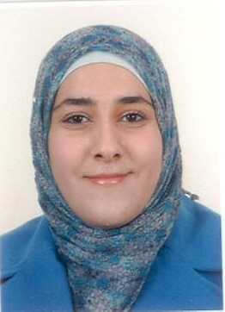

Curriculum vitae

**Objective**

Work in an environment that challenges me to continue learning, at the same time be able to help and learn as much as I can from my peers. To create a workplace that is in continual growth with opportunities for advancements.

**Education Qualifications**

* October 2008- January 2012

University of Jordan, Amman/Jordan.

Bachelor’s degree of English Language and Literature, with an average of 3.5 points (Rating: high very good).

* 2006- 2008

Sukianah Bent Al- Hussein Secondary School, Amman/ Jordan.

Passed the public secondary certificate examination, the scientific branch, with an average of 93, 5 %.

**Skills and Achievements**

* Distinguished **interpersonal skills.** Participated in the “Peer Tutor Program” conducted by CIEE for its non- native speakers during the Fall semester of 2011.Cooperated as a minor coach in the poetry and Quran recitation competitions during school. Acquired excellent experience in performing presentations through university assignments.
* Developed good **team work skills**, through successfully completing the “English in Action 3-day camp” conducted by The Family International in cooperation with UNRWA Education Development Center in January 2006.
* **Leadership skills**. Worked as a group leader for university projects in different courses.
* **IT Skills**. Very good knowledge of MS Office (Access, Excel, FrontPage, Power Point, and Word).
* **Languages.** Arabic: mother tongue,

English (spoken and written): excellent, and

good French.

**Leisure Pursuits**

Reading or watching movies.

**References available upon request**